Winter Wilco 2014 | 
Budget 2014 |  |  | 
Servicing tax compliance  Inland Revenue's role in ensuring tax compliance receives a continued vote of confidence with an additional $132m over the next 5 years. $48.6m of this is earmarked to shore up IRD's tax compliance activities and $84m to cover tax write-offs. The Government is also committed to a business transformation of Inland Revenue, modernising its computer system and processing systems at an estimated cost of $1.5b over time. |  | Cheque duty abolished  Cheque duty will be abolished from 1 July 2014. No duty applies to other payment methods and this simply tidies away a compliance cost. While most businesses have been using other payment methods for some years, enough people still use cheques that the cost of removing the duty is estimated at $15.5 million over four years.

ACC levy changes
The detail is a little vague here but the intention is for levy rates to decrease over the 2014/2015 and 2015/16 levy years and the focus is on motor vehicle levies. There's no definitive pronouncement as to an exact rate of reduction and it seems the detail will be worked out following ACC's public consultation. The Minister of Finance has signalled that the average ACC levy for a private motor vehicle could fall by $130 a year from 1 July 2015.

Changes for business
The changes for business relate mainly to encouraging innovation by making it easier for business to take a chance on research and development. This is supported by funding for science research and increases to tertiary education spending for tuition subsidies in science and agriculture. There's also increased spending to New Zealand Trade and Enterprise to support domestic businesses seeking to break into overseas markets, especially in typically underdeveloped markets such as China, South America and the Middle East.

Family focus
On the home front there are changes to parental tax credit and parental leave with effect from 1 April 2015:
- the parental tax credit will increase from $150 a week to $220 a week, and the payment period will be extended from eight weeks to 10 weeks. This will increase the total credit from $1,200 to $2,200
- in addition, the abatement rules will be changed to better target the parental tax credit towards low- to middle-income families. A couple having their second child, for example, will not receive any payments if together they earn more than $99,847
- on 1 April 2015 paid parental leave will be extended from 14 weeks to 16 weeks and on 1 April 2016 to 18 weeks
- eligibility has been extended to include 'home for life' caregivers and people in less regular jobs, such seasonal and casual workers, workers with two employers and workers who have recently changed jobs

Tax Talk
ACC and rental income  Do you have income from rental? You may be wondering about why ACC collects levies from rental income. It comes down to whether your rental income is classified as 'active' or 'passive'. ACC levies active rental income but not passive rental income.  The difference? Rental income is classified as active when you put in some effort for it. For example, that might be mental and/or physical work collecting rents, inspecting the property, arranging for maintenance, finding tenants and so on. Where there's not this degree of effort - for instance, where you have a property manager in place - the income is classified as passive.  If you're running the rental property through a company, and distribute the income as shareholder salary, this would also be levied as active income. Where income from 'passive' rental has been distributed to the shareholder as dividends, these are not subjected to ACC levies.  If you have income from rental properties but you're unsure whether it's considered active or passive, please contact us and we can look at your situation. |  | 
Employer registration - just part of making it easier  The Government has extended online services to build employer registration into the process of incorporating a new company.  Up to now, companies have been able to register for income tax and GST and obtain their IRD/GST number when incorporating online on the Companies Office website. But the process has then required a visit to Inland Revenue’s website to register for PAYE and FBT as an employer, entering all over again information which the company has only just provided to the Companies Office. The new employer registration service means new companies only have to enter this information once.  This is part of the Better Public Services initiative to cut paperwork and its associated costs, following on from the introduction of the New Zealand Business Number (NZBN). If the news about the NZBN has passed you by, it's an initiative to assign a single identifying number for all businesses in New Zealand. In December 2013 all 1.1 million companies in New Zealand were allocated an NZBN. However, around half of New Zealand businesses are sole traders, partnerships and trusts.  Whatever kind of entity your business is, you don't have to do anything differently. At the moment, the NZBN will not replace any ACC, GST or IRD numbers that you use to identify your business to various government agencies. However, the plan is to allow the NZBN to be the main identifier for businesses eventually and that you will be able to use your NZBN with customers, suppliers and government agencies. The Government hopes the NZBN will mean businesses spend less time and effort on filling out forms and more time and effort on business. They've committed to reducing the cost of doing business with government by 25 per cent by 2017. | 
Timely Reminders
31 May: FBT returns due
30 June: Last date for employers to elect to pay FBT annually
Are you keeping track of the usage of your mixed use asset? (If you have one) Call us for hints on how to do this fuss-free if we haven't talked already.
I don't measure a man's success by how high he climbs but how high he bounces when he hits bottom.
George S. Patton

Update on changes to financial reporting
You may have heard about changes to the financial reporting legislation. In the short term, many people are finding it a bit hard to work out how or whether the changes affect them.
The requirements are changing for some businesses that used to have to file financial statements based on the New Zealand version of International Financial Reporting Standards (NZ IFRS). For example, your requirements have changed if your business:
- has less than $30m in turnover or less than $60m in assets, or
- is a subsidiary of a multi-national company and your annual revenue is $10m or less, your assets $20m or less
Inland Revenue has said businesses like this won't have to file financial statements based on NZ IFRS, but do have to prepare financial accounts to the standard of IRD's minimum reporting requirements. You may see some changes to the way your financial statements are presented while we transition to the new regime.
Your bank, of course, will still be interested in seeing financial statements, as will any investors. And business owners, boards and shareholders will still need enough information to have a good grasp of how the business is progressing against key financial targets.
Talk to us about how the financial reporting changes affect you.

Options for financial reporting for companies
The changes to financial reporting have had a knock on effect, driving changes to reporting requirements for companies from accounting periods beginning on or after 1 April 2014. Some companies have options about which financial reporting regime they fall under or about whether or not they will have an audit. But, if you want to exercise your options, it's important to have the paperwork straight within the timeframe allowed.
Opting out
Companies with 10 or more shareholders default to audited NZ IFRS, but are in a position to opt out of the NZ IFRS regime and/or the audit if at least a 95% majority of the shareholders vote to do so and pass the required company resolution.
Most large companies may opt out of an audit with a similar 95% resolution. 'Large' companies must prepare financial statements based on NZ IFRS in any case. This is what happens already, but the definition of 'large' has changed. Call us to find out whether your company will be 'large' if (including subsidiaries) your sales or assets will exceed $10 million.
Opting in
Companies that don't qualify as 'large' under the legislation, and that have fewer than 10 shareholders don't have to comply with NZ IFRS or have an audit. However, they may opt in to the regime if shareholders of the company holding at least 5% of the voting shares require the company to comply.
Getting the timing right
Company resolutions are required, whether opting in or opting out. The resolutions to opt in or opt out must be passed well before the accounts are prepared. The date of the choice is critical. In many cases it will be the date of the company's annual meeting, but in some circumstances it can be earlier.
The rules for counting shareholders are tricky, too, so if you think you may be affected by the new laws call us today.

Business Perspective

Reform Fitness
Jane Bingham and Lane Gibson opened Reform Fitness in 2011. As partners in crime both professionally and personally, Lane and Jane were exposed to this specific form of exercise while living abroad in London. Both trained in a range of sport medicine and rehabilitation, they instantly fell in love with it. When visas expired and the longing for home became too strong, a dream formed to look at starting up a studio back home in New Zealand, 'At that point, there was nothing quite like it being done back here.'
The pair are both from Taranaki, but weren't sure it was the ideal location for the new venture. After research and deliberation, the selected destination was Mount Maunganui. Initially it was just the two of them, but they have since added a third trainer to the team and increased the number of pilates machines from 5 to 7.
At first glance into a reformer pilates studio, it may appear that you're looking into some sort of torture chamber. Speak to some of the class attendees and they might say that, in fact, that is exactly what it's like. Although it's a gruelling workout, the results speak for themselves and the majority soon find themselves hooked.
The machines, or beds, are kitted with ropes, pulleys and springs that take the holistic approach of mat pilates to a whole new level. It's a high intensity full body workout that encourages strength, toning, flexibility and coordination. The benefits extend to assist with rehabilitation and enhance ease of movement in day-to-day life.
As any new business will tell you, it's not always plain sailing, but the duo have been lucky not to have too many grand scale challenges. The biggest hurdle though is the next one, taking the business to the next step. 'We are currently looking for a bigger studio but we don't want to plunge into anything too quickly. We want to be sure we can still provide the same level of service to our clients without changing too much.’ And keeping clients happy is clearly of the utmost importance, ‘we have a high expectation on ourselves to give our clients excellent service. Seeing them return each week gives us immense satisfaction, plus they’re great fun to be around, so it makes getting up at the crack of dawn well worth it!'  The successful pair have sound advice for small businesses starting out, 'set goals, both short and long term. Have a backup plan and although it sounds dreary, plan for the worst-case scenario so you've got steps in place to deal with anything as it arises. Set clear and realistic financial goals and have a "fold your cards" point to avoid getting in too deep.'  Although Jane and Lane are driven and independent, they understand the importance of help from the right people. ‘We would highly recommend any business to have an accountant. Making sure you cover all your bases when it comes to tax can be hard, and this is something your accountant can take care of for you. And our accountant keeps us out of jail!' |  | 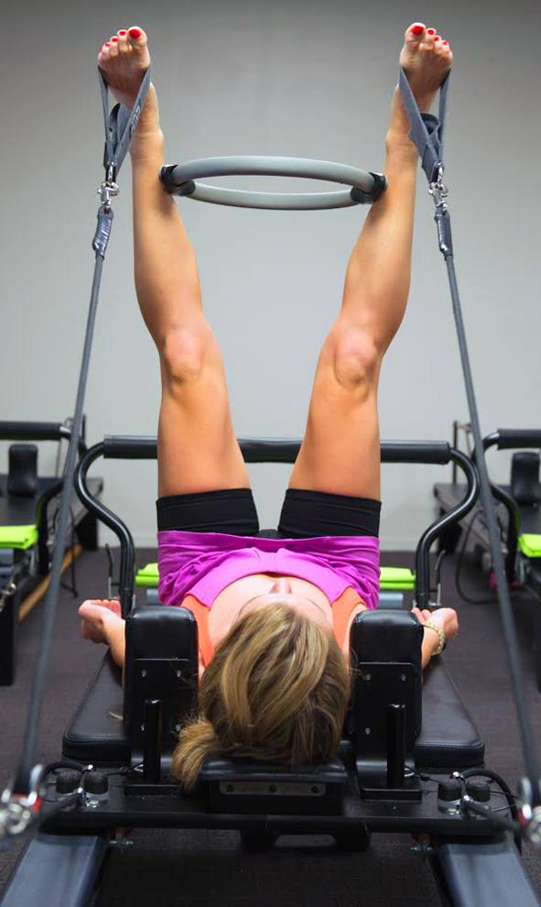
Reform Fitness in Mount Maunganui is one to watch with a plan to take their business to great heights. Currently running 35 pilates classes and 15 to 20 personal training sessions per week, the intent is to become a one stop shop for health and fitness. As Jane says, ‘the next step is branching out to bigger premises then hopefully other cities, eventually going nationwide. The fear of failure is huge but the only way to go is to take a risk.'
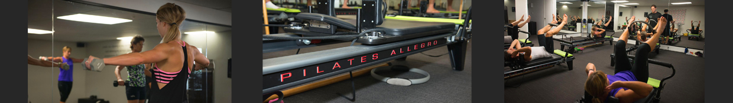
Disclaimer  This publication has been carefully prepared, but it has been written in general terms only. The publication should not be relied upon to provide specific information without also obtaining appropriate professional advice after detailed examination of your particular situation. | www.lsca.co.nz

