Wilco Special Alert  Livestock Herd Scheme 2014 |  |  |  |  | 
The IRD have recently announced this year’s livestock Herd Scheme Values and we think this is a great opportunity to update you on the latest movements. The Herd Scheme Values are the National Average Market Values as determined by a process involving a review of the livestock market as at 30 April.
Dairy Cattle  Following the drop in values after the widespread 2012/2013 drought we have seen an increase in values once again in the 2014 National Average Market Values (Herd Scheme Values). Mixed age Friesian cows have increased by 4.8% to $1,963 and mixed age Jersey cows by 9.5% to $1,782.  Following last year’s significant drop in rising one year heifers we have seen a modest increase this year - with Friesian heifers increasing by 6.1% to $946.  While we have seen some dairy herds being sold for in excess of $2,000 per head, the herd values are an average throughout the country. Given that some parts of the country were once again hit by summer droughts the average is perhaps a bit lower than some commentators were expecting. If new herds have been purchased at values in excess of $2,000 per head there may be an opportunity to move these animals to the herd scheme with minimal tax impact.  The values for dairy cattle over this and the previous three years have shown a fundamental shift in the historic value of animals. The average of the last four years for a mixed age Friesian cow is $1,939 compared to the previous four year average of $1,521. |  |  |  |  |  |  | 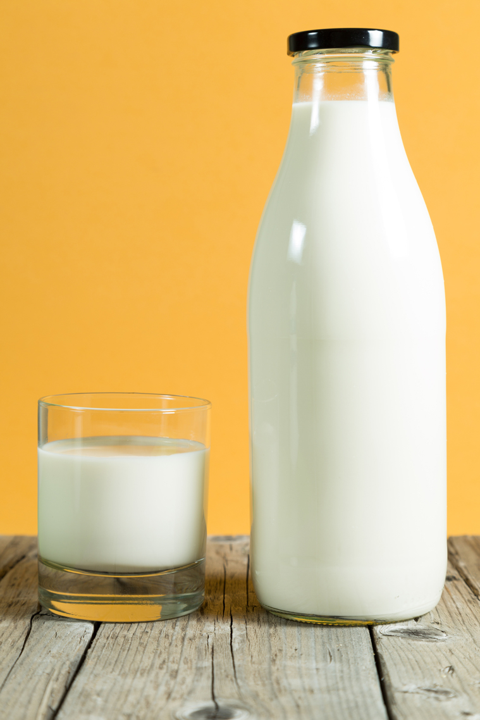
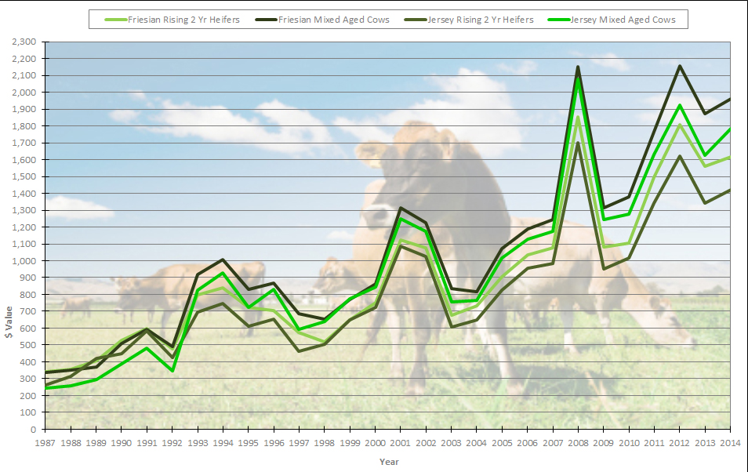
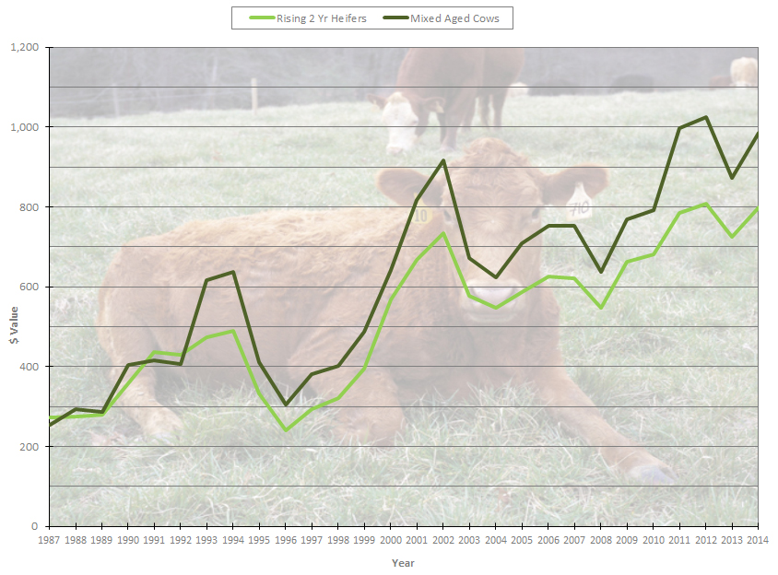 | Beef Cattle  Following last year’s drop in value we have seen an increase in values again this year - almost back to where they were in 2012. The value for a mixed age beef cow has increased from $872 per head to $986 (13% increase) with rising one year heifers increasing from $456 to $506 (11% increase) per head.  Demand for cattle following the widespread 2012/2013 drought has no doubt played a big part in these increases as farmers restock.
 | 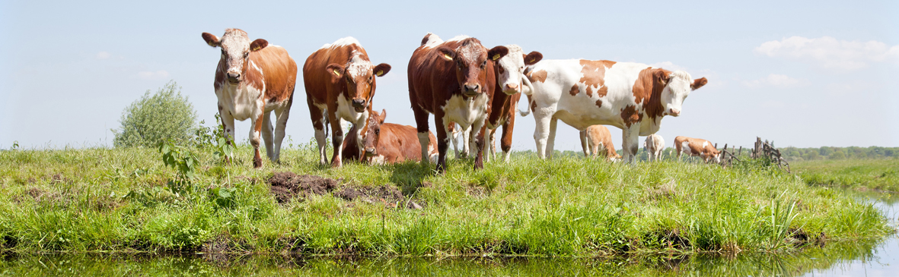
Sheep  As with other categories of livestock, we have seen good increases in sheep values as demand increases following the selling off of capital livestock during the 2012/2013 drought. Two tooth ewes have increased by 8.3% to $131 per head and mixed age ewes by 15.7% to $118 per head. |  |  |  | 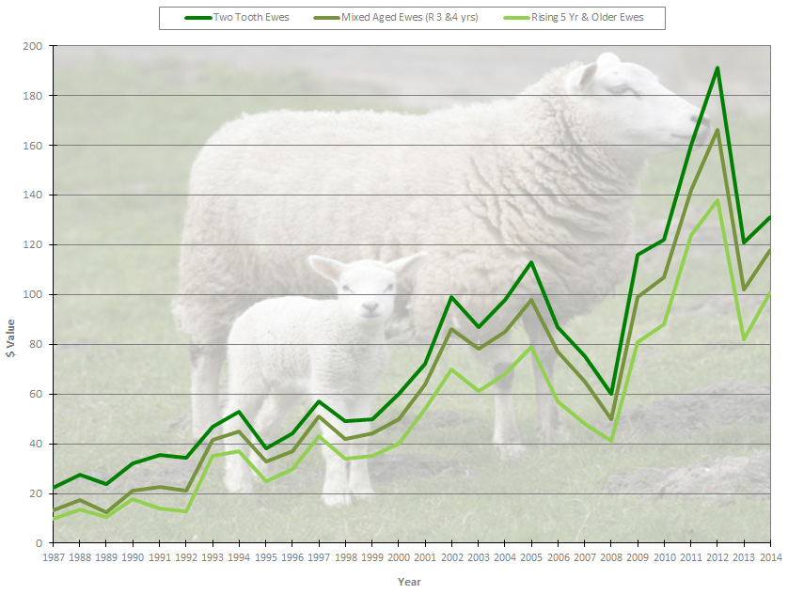
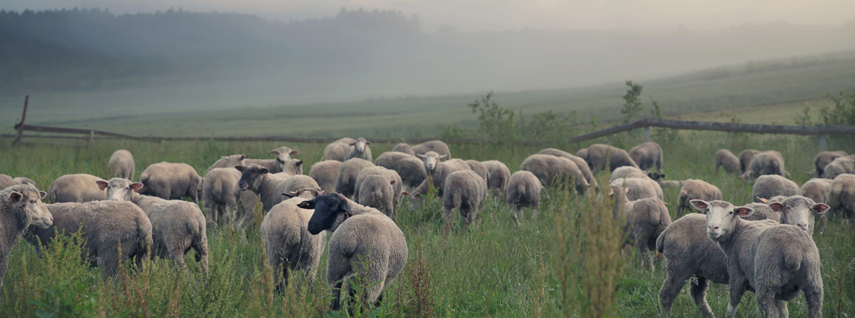
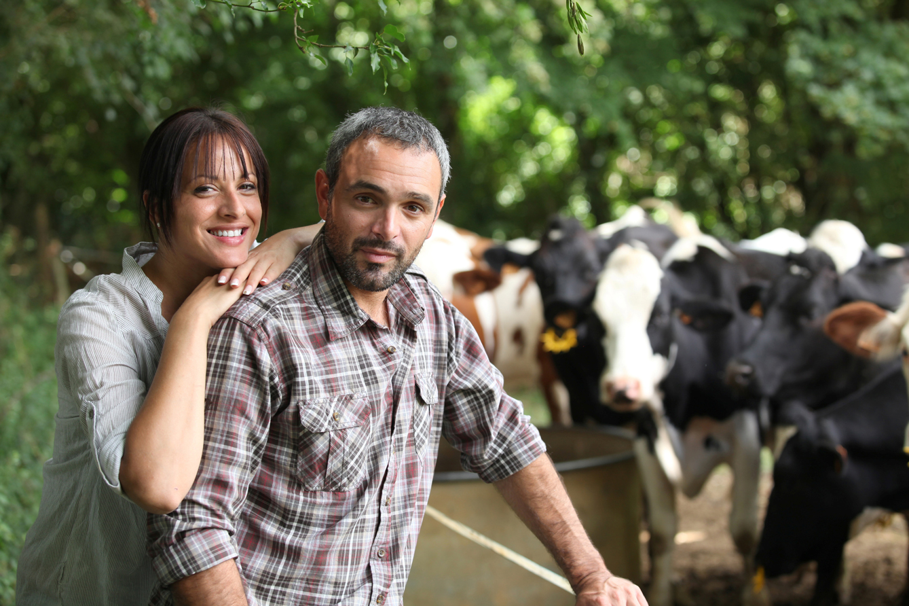 |  | General Summary  Careful consideration needs to be given to your livestock election choices. Even though changes were made to the Herd Scheme in recent years, there is still flexibility around how to value increases in numbers - if you increase your numbers during the year you are able to choose an alternative valuation option to value that increase. Whether you take that option or you elect to value the increase using herd values will depend on a number of factors - such as:  - where we are in the cycle of livestock values (e.g. at the bottom, or at the top)  - if the increase is a permanent or a temporary one  - your longer term intentions  As the decision is clearly one that should be made on a case by case basis, we will naturally discuss your valuation options with you on review of your 2014 financial statements and taxation returns.
Disclaimer  This publication has been carefully prepared, but it has been written in general terms only. The publication should not be relied upon to provide specific information without also obtaining appropriate professional advice after detailed examination of your particular situation. |  |  |  |  |  | www.lsca.co.nz

